**Temperature Sensor DS18B20**

**Working: (**[**https://wiki.eprolabs.com/index.php?title=DS18B20_Temperature_Sensor**](https://wiki.eprolabs.com/index.php?title=DS18B20_Temperature_Sensor)**)**

The core functionality of the DS18B20 is its direct-to-digital temperature sensor. The resolution of the temperature sensor is user-configurable to 9, 10, 11, or 12 bits, corresponding to increments of 0.5°C, 0.25°C, 0.125°C, and 0.0625°C, respectively. The default resolution at power-up is 12-bit. The DS18B20 powers up in a low power idle state. To initiate a temperature measurement and A-to-D conversion, the master must issue a Convert T [44h] command. Following the conversion, the resulting thermal data is stored in the 2-byte temperature register in the scratchpad memory and the DS18B20 returns to its idle state. If the DS18B20 is powered by an external supply, the master can issue “read time slots” after the Convert T command and the DS18B20 will respond by transmitting 0 while the temperature conversion is in progress and 1 when the conversion is done.

**Features: (**[**https://wiki.eprolabs.com/index.php?title=DS18B20_Temperature_Sensor**](https://wiki.eprolabs.com/index.php?title=DS18B20_Temperature_Sensor)**)**

* Power supply range is 3.0V to 5.5V
* Measures temperatures from -55°C to +125°C. Fahrenheit equivalent is -67°F to +257°F
* ±0.5°C accuracy from -10°C to +85°C
* Converts 12-bit temperature to digital word in 750 ms (max.)
* Can be powered from data line
* Alarm search command identifies and addresses devices whose temperature is outside of programmed limits (temperature alarm condition)

**Result**:

This sensor is interfaced using One Wire protocol and the output is in digital form.

.

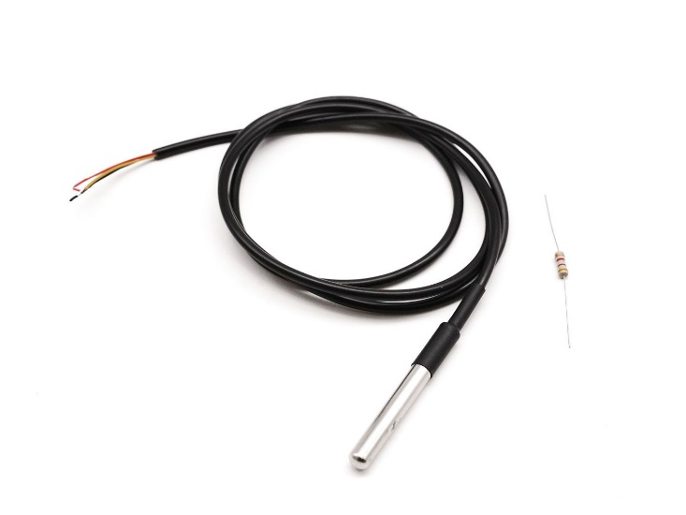

**UV Sensor ML 8511**

**Working: (**[**https://how2electronics.com/uv-sensor-ml8511-arduino-for-uv-ray-intensity-measurement/**](https://how2electronics.com/uv-sensor-ml8511-arduino-for-uv-ray-intensity-measurement/)**,** [**https://cdn.sparkfun.com/datasheets/Sensors/LightImaging/ML8511_3-8-13.pdf**](https://cdn.sparkfun.com/datasheets/Sensors/LightImaging/ML8511_3-8-13.pdf)**)**

The ML8511 is a UV sensor, which is suitable for acquiring UV intensity indoors or outdoors. The ML8511 is equipped with an internal amplifier, which converts photo-current to voltage depending on the UV intensity. This unique feature offers an easy interface to external circuits such as ADC. In the power down mode, typical standby current is 0.1μA, thus enabling a longer battery life.

UV Radiation or Ultraviolet light radiation occu rs from **10nm to 400nm** wavelength in the electromagnetic spectrum. The **ML8511 sensor** is very easy to use. It outputs an analogue voltage that is linearly related to the measured UV intensity **(mW/cm2)**.

This sensor detects **280-390nm** light most effectively. This is categorized as part of the UVB (burning rays) spectrum and most of the UVA (tanning rays) spectrum. It outputs an analogue voltage that is linearly related to the measured UV intensity (mW/cm^2)

**Features: (**[**https://cdn.sparkfun.com/datasheets/Sensors/LightImaging/ML8511_3-8-13.pdf**](https://cdn.sparkfun.com/datasheets/Sensors/LightImaging/ML8511_3-8-13.pdf)**)**

• Photodiode sensitive to UV-A and UV-B

• Embedded operational amplifier

• Analog voltage output

• Low supply current (300μA typ.) and low standby current (0.1μA typ.)

• Small and thin surface mount package (4.0mm x 3.7mm x 0.73mm, 12-pin ceramic QFN)

**Result**:

Maximum supply/input voltage = -0.3 to +4.6 V

Max o/p voltage = 2.08 to 2.32 V

Maximum o/p range (in mW/cm^2) = 0 – 15

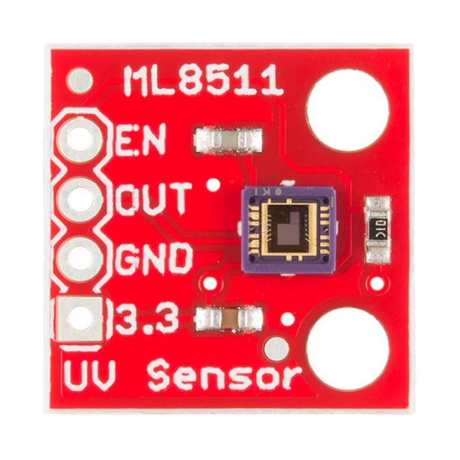

**Light Sensor BH 1750**

**Working: (**[**https://www.mouser.com/datasheet/2/348/bh1750fvi-e-186247.pdf**](https://www.mouser.com/datasheet/2/348/bh1750fvi-e-186247.pdf)**)**

BH1750FVI is a digital Ambient Light Sensor IC for I2C bus interface. This IC is the most suitable to obtain the ambient light data for adjusting LCD and Keypad backlight power of Mobile phone. It is possible to detect wide range at High resolution. (1 - 65535 lx).

BH1750 works with a supply voltage of 2.4V to 3.6V. BH1750FVI is the main module of the sensor which requires 3.3V for working. So, a voltage regulator is used in the circuit. SDA and SCL are the pins used for I2C communication. 4.7kΩ of pull-up resistors are used with these pins.

There are three types of measurement modes for BH1750. H-resolution mode2 takes 120ms for measurement and has a 0.5 lx of resolution. H-resolution mode also takes 120ms for measurement but its resolution is 1 lx. L- resolution takes 16ms for measurement and its resolution is 4 lx. H- resolution mode is more useful in darkness and it can also easily reject noise.

**Features: (**[**https://components101.com/sensors/bh1750-ambient-light-sensor**](https://components101.com/sensors/bh1750-ambient-light-sensor)**)**

* Power Supply: 2.4V-3.6V (typically 3.0V)
* Less current consumption: 0.12mA
* Measuring Rang: 1-65535lx
* Communication: I2C bus
* Accuracy: +/-20%
* Built in A/D converter for converting analog illuminance in the digital data.
* Very small effect of IR radiation
* Highly responsive near to human eye.

**Result**:

Max I/p voltage = 4.5 V

Communicates on i2c protocol

O/p range is from 0 – 65535 lx.

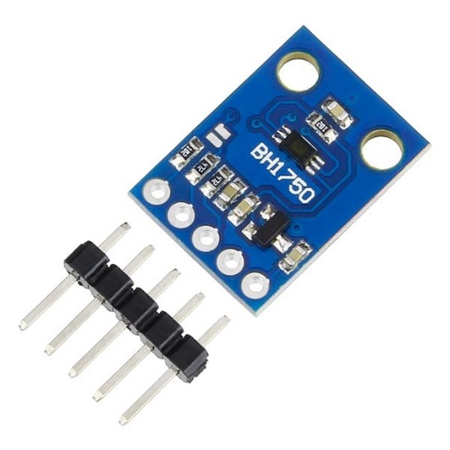

**Air Sensors BME 280**

**Working: (**[**https://www.bosch-sensortec.com/media/boschsensortec/downloads/datasheets_1/bst-bme280-ds002.pdf**](https://www.bosch-sensortec.com/media/boschsensortec/downloads/datasheets_1/bst-bme280-ds002.pdf)**)**

The BME280 is as combined digital humidity, pressure and temperature sensor based on proven sensing principles.

The humidity sensor provides an extremely fast response time for fast context awareness applications and high overall accuracy over a wide temperature range. The pressure sensor is an absolute barometric pressure sensor with extremely high accuracy and resolution and drastically lower noise than the Bosch SensortecBMP180. The integrated temperature sensor has been optimized for lowest noise and highest resolution. Its output is used for temperature compensation of the pressure and humidity sensors and can also be used for estimation of the ambient temperature.

The housing of BME 280 consists of air inlet chamber. According to the air sensed by the chamber the parameters like temperature, humidity and pressure are calculated.

With the help of pressure readings it can also estimate altitude above the sea level.

**Features: (**[**https://www.bosch-sensortec.com/media/boschsensortec/downloads/datasheets_1/bst-bme280-ds002.pdf**](https://www.bosch-sensortec.com/media/boschsensortec/downloads/datasheets_1/bst-bme280-ds002.pdf)**)**

* Package 2.5mm x 2.5mm x 0.93mm metal lid LGA
* Digital interfaceI²C (up to 3.4 MHz) and SPI (3 and 4 wire, up to 10 MHz)
* Supply voltage VDD main supply voltage range: 1.71V to 3.6V VDDIO interface voltage range: 1.2 V to 3.6 V
* Current consumption1.8μA @ 1Hz humidity and temperature 2.8μA @ 1Hz pressure and temperature 3.6μA @ 1Hz humidity, pressure and temperature 0.1 μA in sleep mode
* Operating range-40...+85 °C, 0...100 % rel. humidity, 300...1100 hPa
* Humidity sensor and pressure sensor can be independently enabled / disabled
* Register and performance compatible to Bosch Sensortec BMP280 digital pressure sensor
* RoHS compliant, halogen-free, MSL1

**Result**:

Max supply voltage = -0.3 to +4.25 V

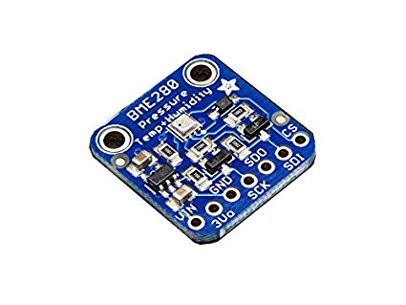Works on i2c interface

Temperature range: -40t to +85 °C

Relative: Humidity: 0 to 100 %

Pressure: 300 to 1100 hPa

**Leaf Wetness Sensor**

**Working: (**[**https://s.campbellsci.com/documents/us/manuals/lws.pdf**](https://s.campbellsci.com/documents/us/manuals/lws.pdf)**)**

The LWS measures the dielectric constant of a zone approximately 1 cm from the upper surface of the sensor. The dielectric constant of water (≈80) and ice (≈5) are much higher than that of air (≈1), so the measured dielectric constant is strongly dependent on the presence of moisture or frost on the sensor surfaces. The sensor outputs a millivolt signal proportional to the dielectric of the measurement zone, and therefore proportional to the amount of water or ice on the sensor surface.

The LWS is designed to approximate the thermodynamic properties of most leaves. If the specific heat of a typical leaf is estimated at 3750 J kg–1 K–1, density estimated at 0.95 g/cm3, and thickness estimated at 0.4 mm, then the heat capacity of the leaf is ≈1425 J m–2 K–1. This heat capacity is closely approximated by the thin (0.65 mm) fiberglass construction of the LWS, which has a heat capacity of 1480 J m–2 K–1. By mimicking the thermodynamic properties of a leaf, the LWS closely matches the wetness state of the canopy.

The sensor closely matches the radiative properties of real leaves. Healthy leaves generally absorb solar radiation in much of the visible portion of the spectrum, but selectively reject much of the energy in the near-infrared. The surface coating of the LWS absorbs well in the near-infrared region, but the white colour reflects most of the visible radiation. Spectroradiometer measurements indicate that the overall radiation balance of the sensor closely matches that of a healthy leaf. During normal use, prolonged exposure to sunlight can cause some yellowing of the coating, which does not affect the function of the sensor. The surface coating is hydrophobic — similar to a leaf with a hydrophobic cuticle. The sensor matches the wetness state of these types of leaves, but may not match the wetness duration of pubescent leaves or leaves with less waxy cuticles.

**Features: (**[**https://s.campbellsci.com/documents/us/manuals/lws.pdf**](https://s.campbellsci.com/documents/us/manuals/lws.pdf)**)**

* Imitates characteristics of a leaf.
* Does not require painting or calibration of individual sensors.
* Detects trace amounts of water or ice on the leaf surface.
* Settling time: 10ms
* Operating Temperature: -40 to 60 degree C
* Operating Voltage : 5 v (Nominal)
* Output : 1.95 to 4.4 V

**Result**:

Max I/p voltage = 5 V

For 800KHz for air: 4.46v; dry hand: 3.2; wet swob: 2.5

For 1000KHz for air: 4.4v; dry hand: 3.74; wet swob: 2.45

For 500KHz for air: 4.4v; dry hand: 4; wet swob: 2.4

For 600KHz for air: 4.4v; dry hand: 4.1; wet swob: 2

For 650KHz for air: 4.4v; dry hand: 4.2; wet swob: 2

For 700KHz for air: 4.4v; dry hand: 4.1; wet swob: 1.95

**LORA RFM96W**

**Features: (**[**https://cdn.sparkfun.com/assets/learn_tutorials/8/0/4/RFM95_96_97_98W.pdf**](https://cdn.sparkfun.com/assets/learn_tutorials/8/0/4/RFM95_96_97_98W.pdf)**)**

* 168 dB maximum link budget.
* +20 dBm - 100 mW constant RF output vs. V supply.
* +14 dBm high efficiency PA.
* Programmable bit rate up to 300 kbps.
* High sensitivity: down to -148 dBm.
* Bullet-proof front end: IIP3 = -12.5 dBm.
* Excellent blocking immunity.
* Low RX current of 10.3 mA, 200 nA register retention.
* Fully integrated synthesizer with a resolution of 61 Hz.
* FSK, GFSK, MSK, GMSK, LoRa and OOK modulation.
* Built-in bit synchronizer for clock recovery.
* Preamble detection.
* 127 dB Dynamic Range RSSI.
* Automatic RF Sense and CAD with ultra-fast AFC.
* Packet engine up to 256 bytes with CRC.

